Research question (1-2 sentences):

Contribution(s) to the literature (2-3 sentences):

Independent variable(s) (list each variable):

Operationalization (list each variable):

Data source(s):

Unit of analysis:

Make a map of the independent variable

Dependent variable(s):

Operationalization:

Data source(s):

Unit of analysis:

Map of dependent variable

Control variable(s):

Operationalization:

Data source(s):

Unit of analysis:

Time span (if applicable):

Main question: Is there a significant increase in the financial investment of China in 2014, when OBOR launched?

Are countries participated in OBOR receiving more financial support from China in 2014 than in 2013?

Did the rest of countries also benefit from the increasing financial support in 2014?

Did countries generally receive greater financial aids from China in 2014? How were the numbers comparing to their historical average?

Known problems:

1 Is there a selection bias in terms of years? What if more recent data is easier to trace? Thus, projects are more easily recorded in more recent years.

Maybe use data like China’s worldwide investment (<http://www.aei.org/china-global-investment-tracker/>) and check the percentage of the amount of total Chinese financed projects across years.

2 Should I calculate the average investment per project in a country or aggregate the amount within a country?

3 There are extremely large investments as outliers. Exclude them or not?

4 Roughly 1000/5000 with no numbers of investment. Shall I also count the number of projects within a country?

Possible Steps: Divide into subsets with different years

Aggregate amount based on countries

T-tests

Data: AidData's Global Chinese Official Finance Dataset, 2000-2014, Version 1.0

Website: <https://www.aiddata.org/data/chinese-global-official-finance-dataset>

Articles using it: <https://blogs.worldbank.org/opendata/where-does-chinese-development-finance-go>

Description: Summary

This dataset tracks the known universe of overseas Chinese official finance between 2000-2014, capturing 4,373 records totaling $354.4 billion. The data includes both Chinese aid and non-concessional official financing. For geolocated data on Chinese project locations, see AidData's Geocoded Global Chinese Official Finance Dataset, Version 1.1.1.

Official Citation

For academic purposes: Dreher, A., Fuchs, A., Parks, B.C., Strange, A. M., & Tierney, M. J. (2017). Aid, China, and Growth: Evidence from a New Global Development Finance Dataset. AidData Working Paper #46. Williamsburg, VA: AidData.

For other (non-academic) purposes: AidData. 2017. Global Chinese Official Finance Dataset, Version 1.0. Retrieved from http://aiddata.org/data/chinese-global-official-finance-dataset.

METADATA

VERSION

Version 1.0

(Most Current Version)

METHODOLOGY

TUFF

SPECIFICATIONS

Publication Date:

Oct 2017

Starting Year:

2000

Ending Year:

2014

Full Description

This dataset captures the known universe of officially-financed Chinese projects in 5 regions of the world from 2000-2014 (including Africa, the Middle East, Asia and the Pacific, Latin America and the Caribbean, and Central and Eastern Europe). It includes concessional and non-concessional sources of funding from Chinese government institutions (including central, state or local government institutions) with development, commercial, or representational intent. More specifically, it captures (a) highly concessional, Chinese development projects that meet the OECD’s criteria for Official Development Assistance (ODA); and (b) officially-financed Chinese projects that lack development intent or are provided with higher interest rates and lower grant elements (i.e. projects that fall within the OECD’s criteria for “Other Official Flows”, or OOF). Chinese ODA represents “Chinese aid” in the strictest sense of the term, but Chinese official finance (ODA and Other Official Flows) is sometimes used as a broader definition of aid. AidData’s dataset allows users to disaggregate Chinese official finance into its constituent parts and determine if they wish to use a narrow or broad definition of aid. This dataset builds off of previous work to track Chinese Official Finance in Africa (versions 1.0, 1.1, 1.1.1, and 1.2).

Methodology Documentation

TUFF—'Tracking Underreported Financial Flows'—is a rigorous, replicable methodology that triangulates open-source information to systematically create project-level data detailing official finance originating from opaque donors and lenders. For high-level guidelines on the TUFF methodology, please see AidData's TUFF Methodology, Version 1.3 document. For specific, step-by-step instructions used by AidData researchers to arbitrate project records, please see the AidData TUFF Coder Instructions, Version 1.3 document.

Funding: This research was funded through generous support from the John D. and Catherine T. MacArthur Foundation, the William and Flora Hewlett Foundation, Humanity United, the Academic Research Fund of Singapore’s Ministry of Education, and the German Research Foundation (DFG) for ”The Economics of Emerging Donors in Development Cooperation” project at Heidelberg University (DR 640/5-1 and FU 997/1-1).

Known Results:

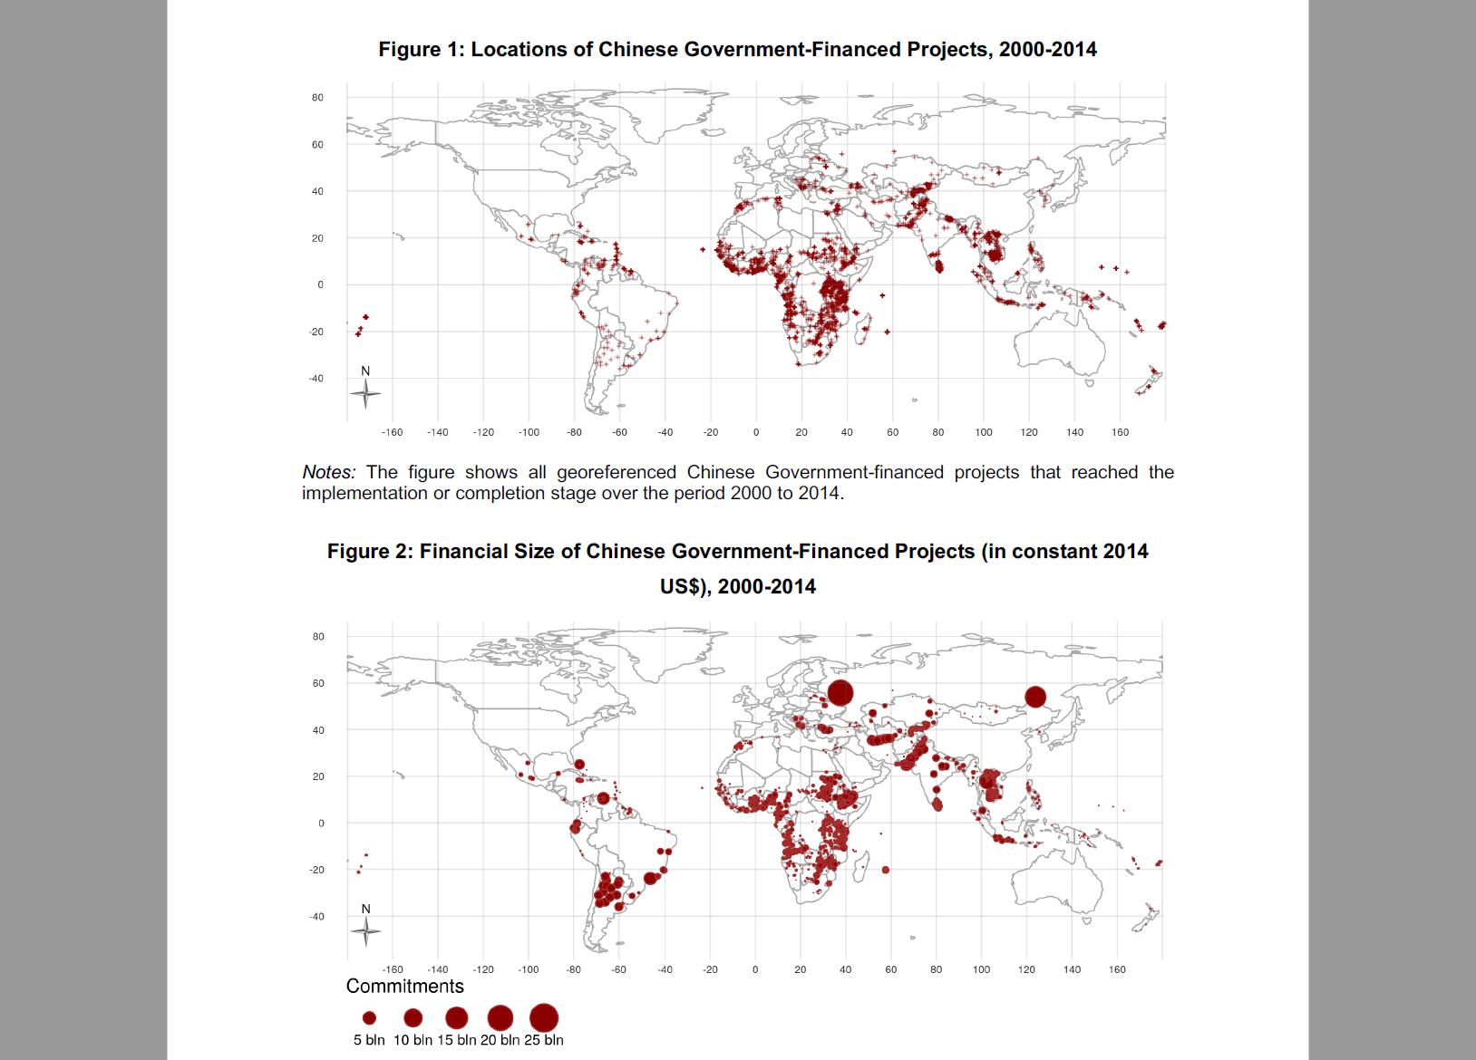

**Backup:** <https://ucsd.libguides.com/c.php?g=90732&p=587103>

OBOR shapefiles / measure distance instead of drawing roads

Ports data & railroads

Geocoded data - AidDATA